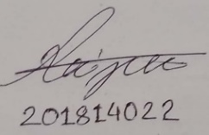  **CSE - 308**

**Assignment - 4 Report**

1. **Problem Statement :**

Take an array of number and Check divisibility for both 2 and 4.If a number is divisible by 2 but not by 4 then the number is only divisible by 2 else the number is both divisible by 2 and 4 or 8.Output will be shown according to the numbers.

1. **Bash Script :**

**#! /usr/bin/bash**

**os=(10 21 24 40 50)**

**arr_len=${#os[@]}**

**for(( i=0 ; i<$arr_len ; i++))**

**do**

**num=${os[$i]}**

**if [ $(( num % 4 )) -eq 0 ]**

**then**

**num2=$((num/2))**

**if [ $(( num2 % 4 )) -eq 0 ]**

**then**

**echo "div by 2,4,8"**

**else**

**echo "div by 2,4"**

**fi**

**elif [ $(( num % 2 )) -eq 0 ]**

**then**

**echo "olny div by 2"**

**else**

**echo "not div by 2,4 or 8"**

**fi**

**done**

1. **References :**

[1] William E. Shotts. Jr.,The Linux Command Line : A Complete

Introduction,Part 1 : Learning The Shell,Vol. 1,no. 6,pp.77-100.